## horizontal line



The Lottery System

Sprint Implementation

**Timeline:30.09.2022-7.10.2022**

Group 6

# 

# INDEX

|  |  |  |
| --- | --- | --- |
| **SL. NO.** | **CONTENTS** | **PAGE NO.** |
| 1 | Overview. . . . . . . . . . . . . . . . . . . . . . . . . . . . . . . . . . . | 2 |
| 2 | Goals. . . . . . . . . . . . . . . . . . . . . . . . . . . . . . . . . . . . . . . | 2 |
| 3 | Purpose. . . . . . . . . . . . . . . . . . . . . . . . . . . . . . . . . . . . | 2 |
| 4 | Target audience. . . . . . . . . . . . . . . . . . . . . . . . . . . . . | 2 |
| 5 | Design overview. . . . . . . . . . . . . . . . . . . . . . . . . . . . .  Dataflow diagram level 0. . . . . . . . . . . . . . . . . .  Dataflow diagram level 1. . . . . . . . . . . . . . . . . .  Flowchart for lottery process. . . . . . . . . . . . . .  Flowchart for main menu. . . . . . . . . . . . . . . . .  Flowchart for participant database. . . . . . . . .  Flowchart for plot database. . . . . . . . . . . . . . . | 3  3  4  5  6  7  7 |
| 6 | System architecture. . . . . . . . . . . . . . . . . . . . . . . . . .  Functions. . . . . . . . . . . . . . . . . . . . . . . . . . . . . . .  Structures. . . . . . . . . . . . . . . . . . . . . . . . . . . . . . . | 8  8  9 |
| 7 | Tools report. . . . . . . . . . . . . . . . . . . . . . . . . . . . . . . . .  Gcov report. . . . . . . . . . . . . . . . . . . . . . . . . . . . .  Splint report. . . . . . . . . . . . . . . . . . . . . . . . . . . . .  Valgrind report. . . . . . . . . . . . . . . . . . . . . . . . . .  Gprof report. . . . . . . . . . . . . . . . . . . . . . . . . . . . | 10  10  11  12  13 |
| 8 | Testing report. . . . . . . . . . . . . . . . . . . . . . . . . . . . . . .  Unit testing report. . . . . . . . . . . . . . . . . . . . . . .  Integration testing report. . . . . . . . . . . . . . . . . | 16  16  16 |
| 9 | Requirement Traceability Matrix. . . . . . . . . . . . . . . | 21 |

# Overview

ZamoLand Development Authority (ZDA) plans to allot 100 plots to people of a small city of 500 households through a lottery. Token will be available on their website on a first_cum-first-serve basis. 300 tokens are available with a serial number in pre-decided range. When the participant grabs a token, a auto-generated confirmation is given. One household can grab only one ticket. In the lottery process, on every call, a token number is auto generated out the 300 available tokens. If the participant who owns the tokens confirms the booking, then the plot is allocated in his/her name or else lottery for the plot is repeated. Once the plot is booked, the plot database is updated, and lottery report is generated. Database is maintained for information regarding the participants as well as the plot details for the plot he won.

# Goals

This project aims at creating and maintaining an automated system for lottery process to ZDA in storing and updating all information about the registered participants, winning participants, the available plots and the allocated plots in an efficient manner. All information stored can be retrieved at any given time.

# Purpose

The purpose of this document is to track and record all the information and events occurring throughout the lottery process and keep the details organized, so that the plots can be allocated to the people smoothly.

# Target Audience

The target audience of this event are the 500 families residing in ZamboLand who are participating in the lottery process. Out of all those families only 300 households are allowed to grab the token for the lottery where only 100 will be able to win and book a plot.

# Design Overview

## 

## 5.1. Data Flow Diagram Level 0(LLD):

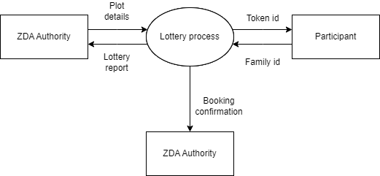

## 

## 

## 

## 

## 

## 

## 

## 5.2. Data Flow Diagram Level 1(HHD):

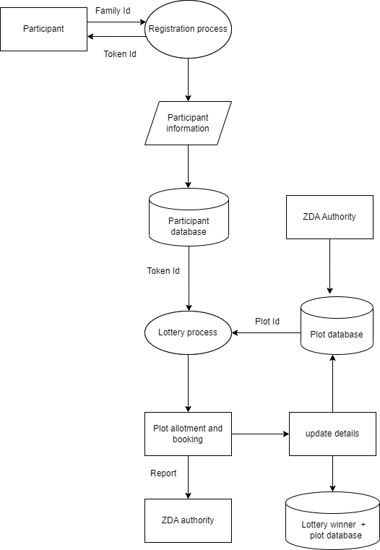

## 

## 

## 

## 5.3. Flowchart for lottery Process:

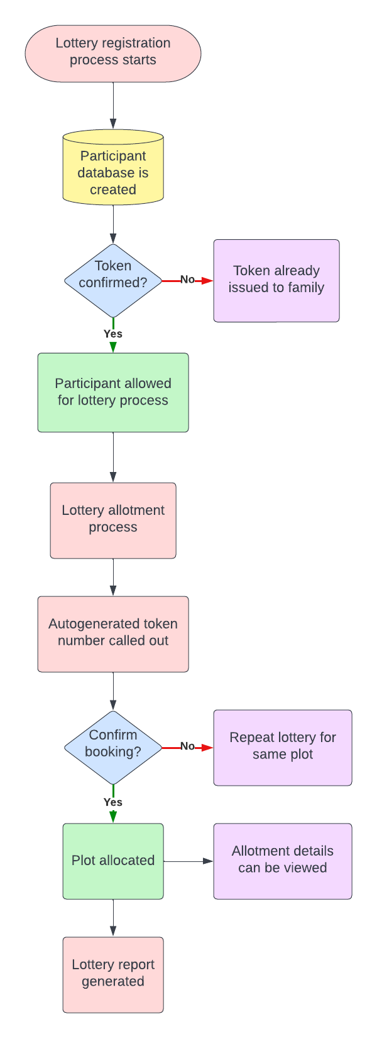

## 

## 

## 5.4. Flowchart for Main Menu:

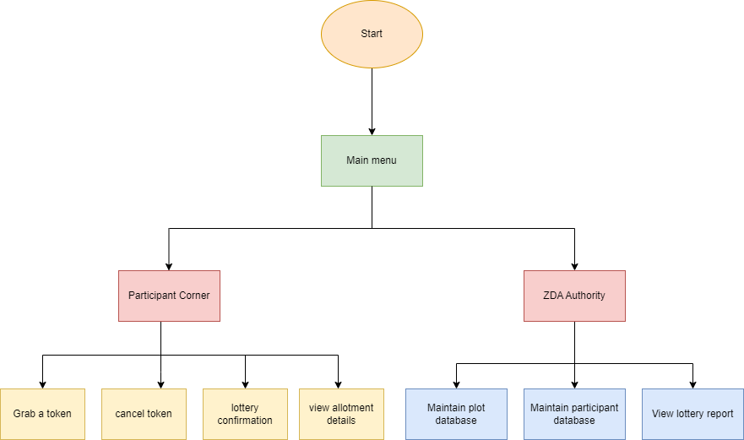

## 

## 

## 

## 

## 5.5. Flowchart for Maintain participant database:

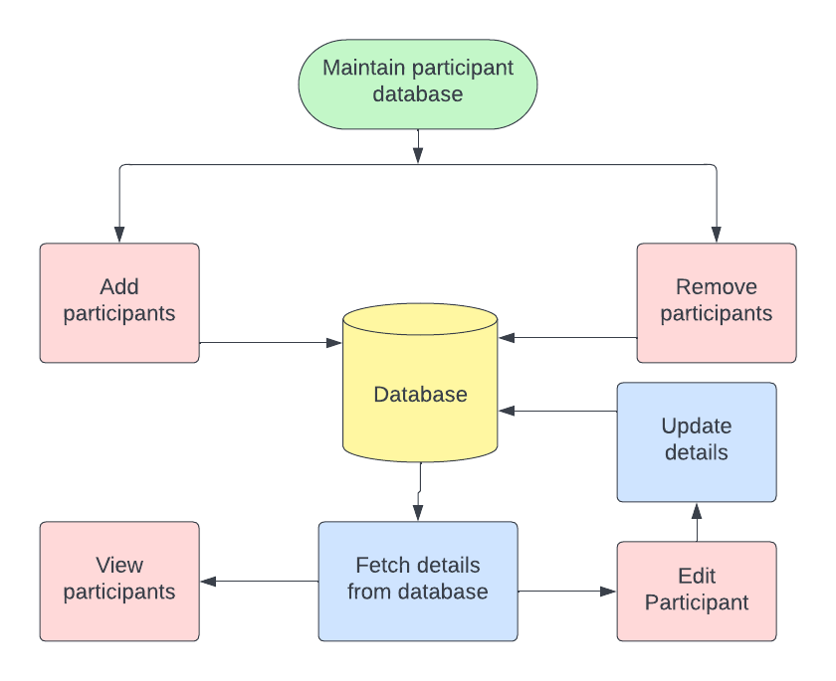

## 5.6. Flowchart for maintain plot database:

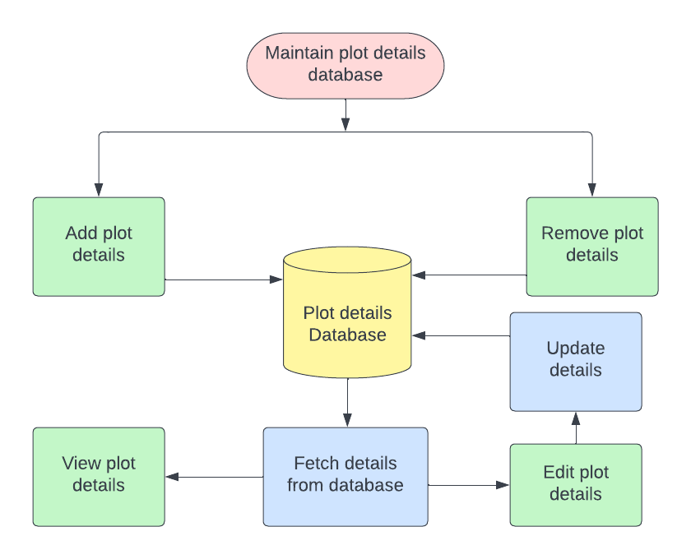

# System Architecture:

## 6.1. Functions:

### **6.1.1. PARTICIPANT CORNER:**

With only 300 tokens up for grabs on the website, only 300 out of 500 households can participate in the lottery process. Every family has a unique family Id and can grab only 1 token. Participants can register in the lottery by entering their family Id and can participate in the process after getting confirmation.

#### 6.1.1.1. Grab a token:

Participant grabs a token in order to register for the lottery using his unique family Id.

#### 6.1.1.2. Cancel token:

If the present date is within 2 days before the actual lottery date, then the participants are not allowed to cancel their token or else their token is canceled and the participant database is updated.

#### 6.1.1.3. Lottery Confirmation:

After the ZDA authority declares the winning lottery number for a plot, the winning family can confirm the booking by paying Rs.50000/- within 5 minutes and the database is updated.

#### 6.1.1.4. View allotment details:

This function displays the plot allotment details of the participant.

### **6.1.2. ZDA AUTHORITY:**

ZDA Authority is responsible for maintaining the databases for the participants and plots by adding, editing, deleting and viewing the details in each database. They have access to the final lottery report and booking confirmation of the plots. ZDA Authorities have to access the admin features by entering the password.

#### 6.1.2.1. Add Plot details:

ZDA Authority can add the information about the plots that are to be won via lottery using admin features. We can get information like plot Id, plot size, price, etc.

#### 6.1.2.2. Edit plot details:

using this function, the features of the plots can be edited by using admin features.

#### 6.1.2.3. Delete plot details:

ZDA Authority can delete the information about a plot.

#### 6.1.2.4. View plot details:

ZDA Authority can view the details of all plots.

#### 6.1.2.5. Add participant details:

The information of the participants are entered into the database by the ZDA authority. Information such as family Id, name,plot no. and price to be paid are found here. The plot no. and price to be paid column are updated automatically after plot allotment.

#### 6.1.2.6. Edit participant details:

ZDA Authority can update the participant information through this.

#### 6.1.2.7. Remove participant:

Details of participants can be deleted from the participant database.

#### 6.1.2.8. View participant details:

ZDA Authority can view information about all participants.

6.1.2.9. Initialise Tokens:

Tokens are generated for the participants.

6.1.2.10 Generate Winning Lottery:

Winning lottery number is generated and matched with token number to declare the lottery winner.

## 6.2. Structures:

### Participant:

This structure is used to store information about the participant of the lottery. It contains structure members like Family_id, name, participated in lottery or not, plot_no., token_no., size of plot and remaining_amount.

### Plot:

This structure contains structure members like plot_no., size of plot, allot, and price of plot in order to describe the features of a plot.

# Tools Report:

## 7.1. Gcov report:

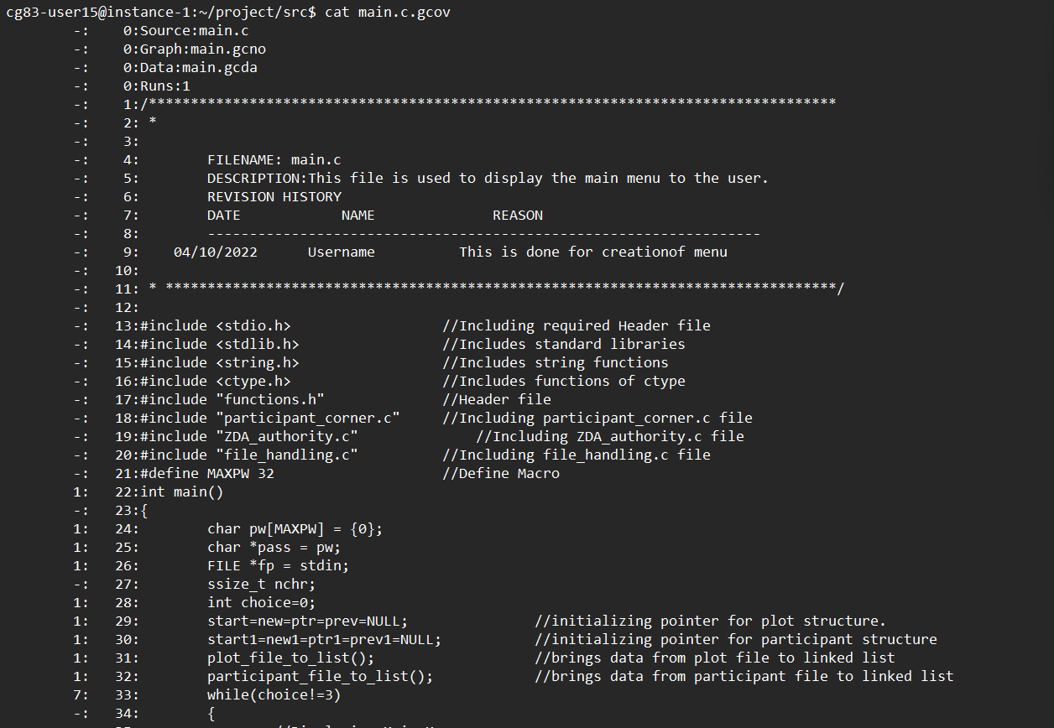

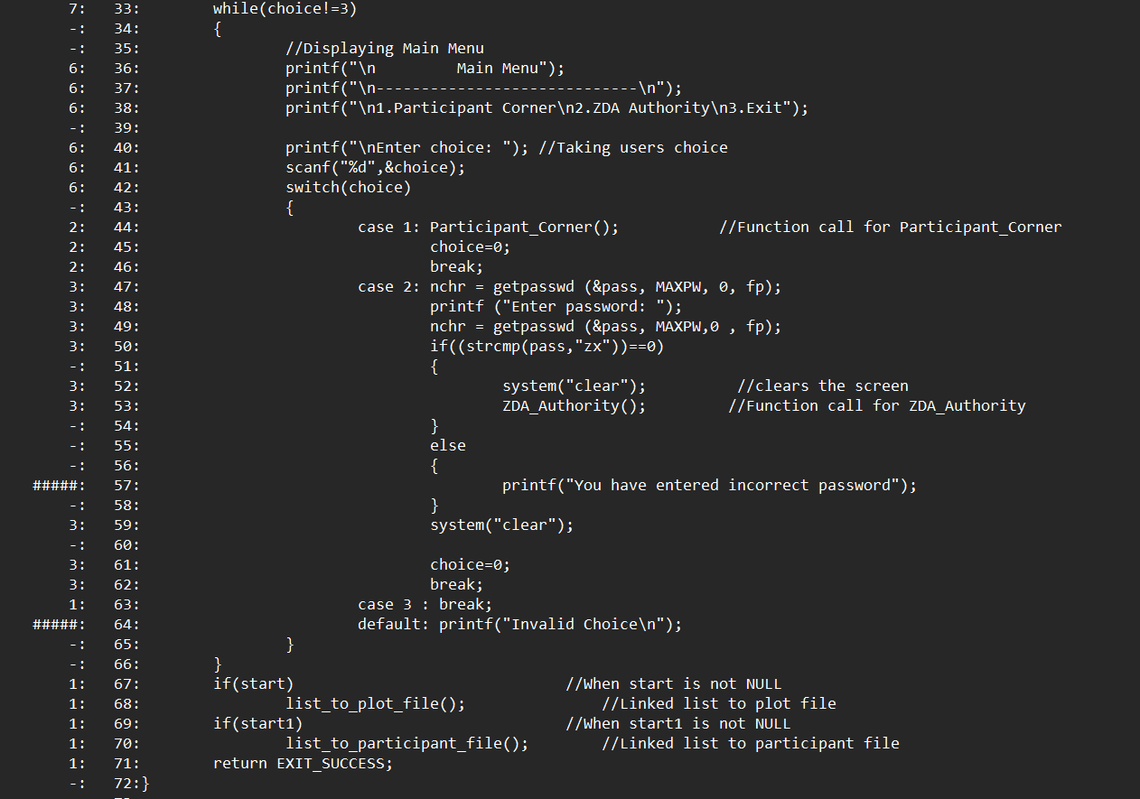

## 7.2. Splint report:

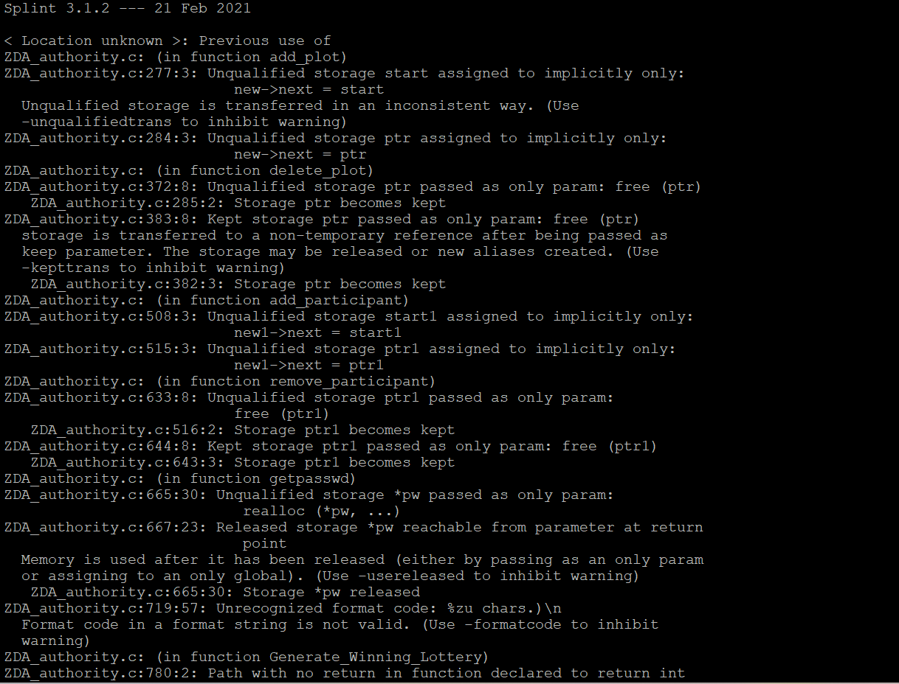

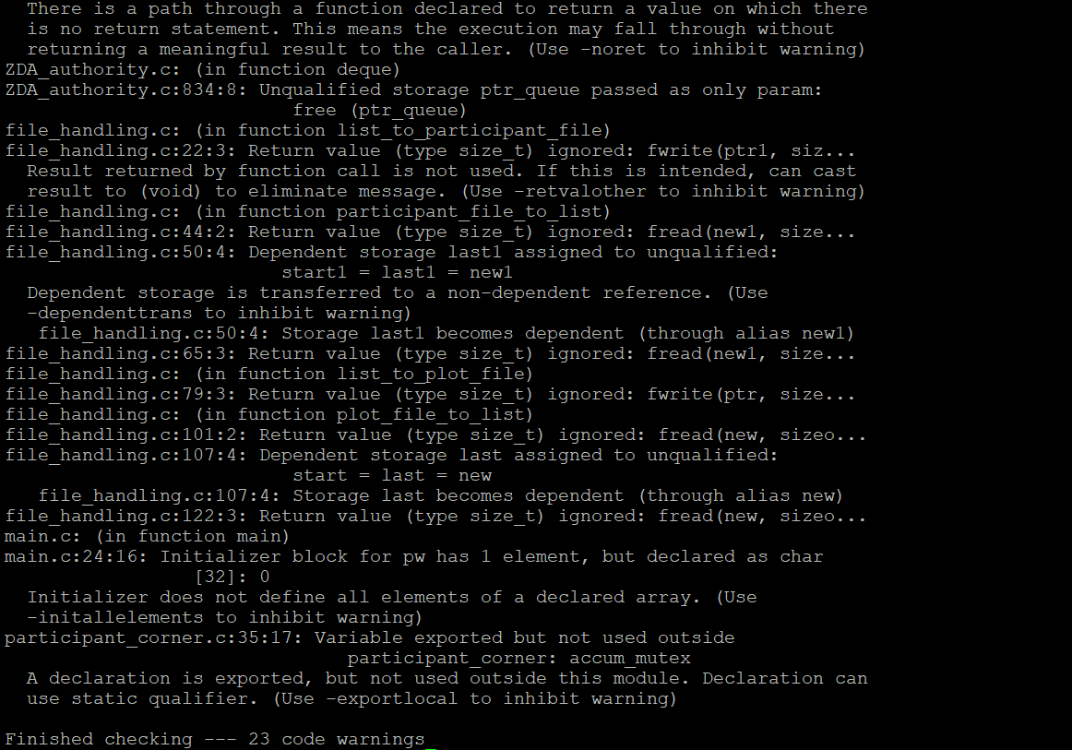

## 7.3. Valgrind report:

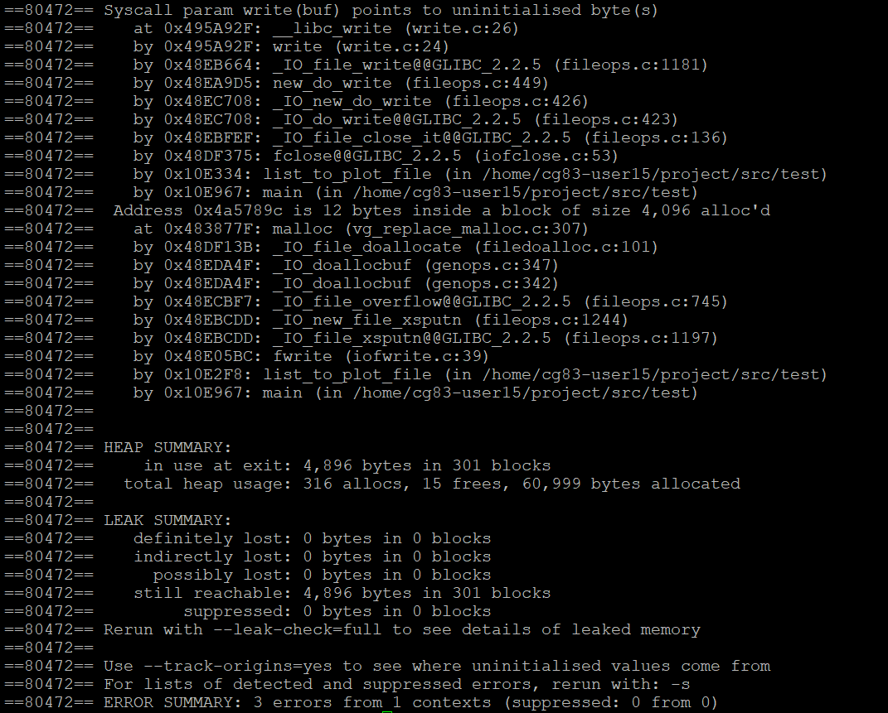

## 

## 

## 

## 7.4. Gprof report:

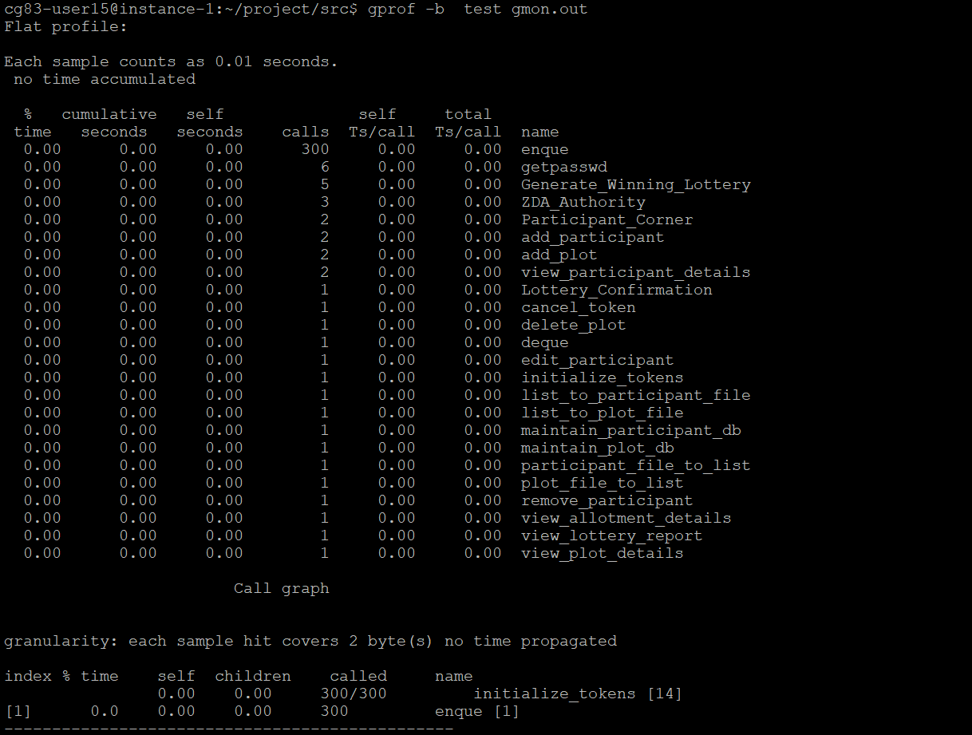

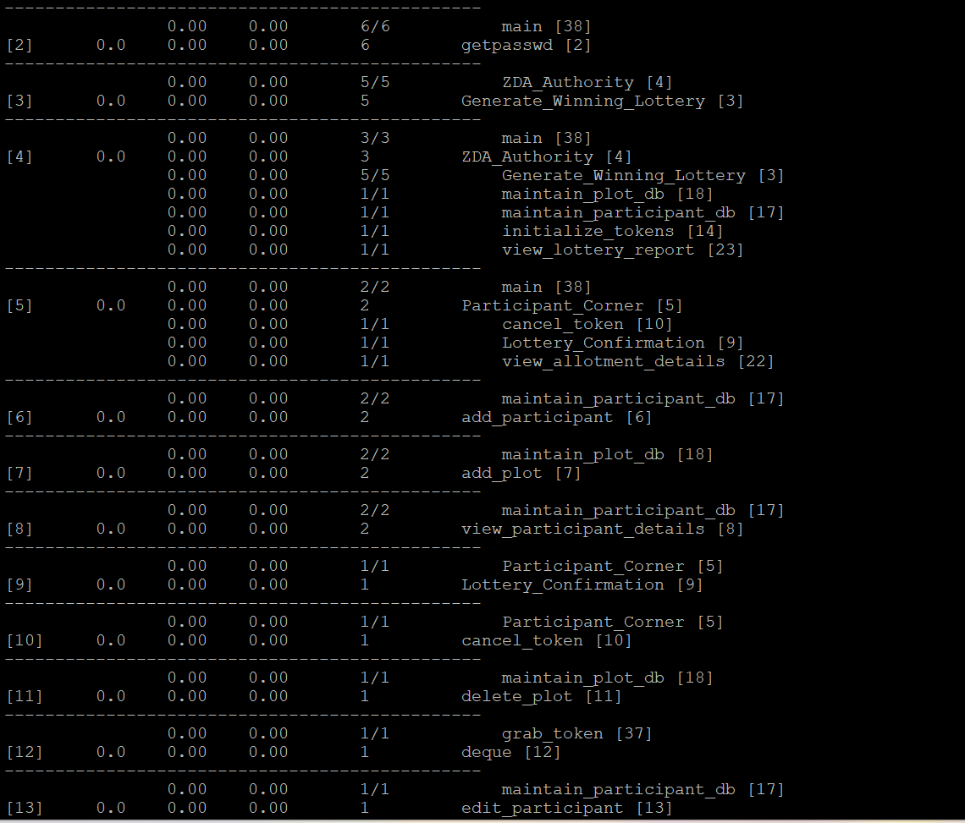

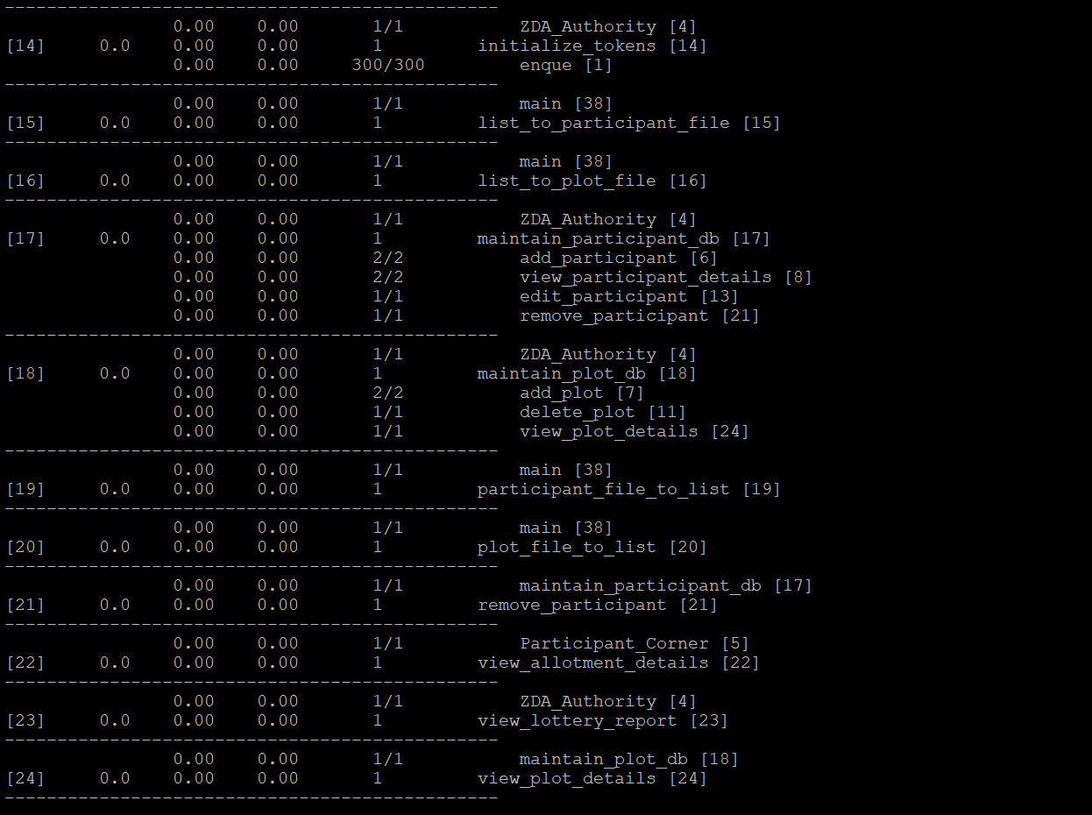

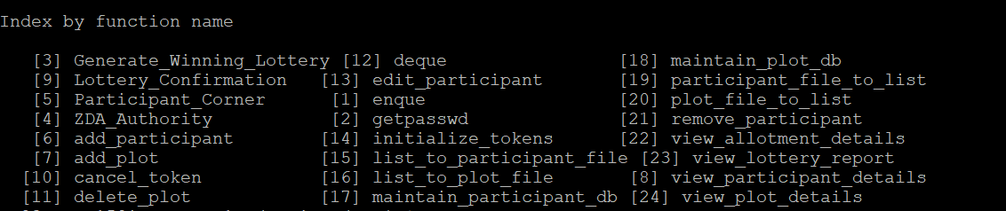

# Testing Report:

## 8.1. Unit testing report:

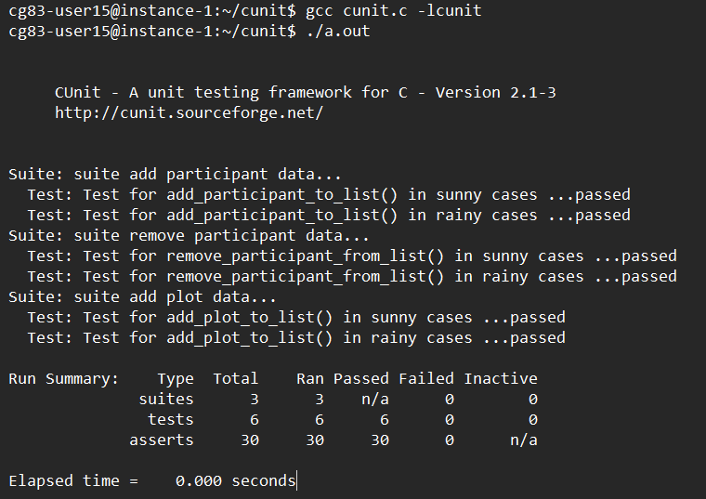

## 8.2. Integration testing report:

Case-1

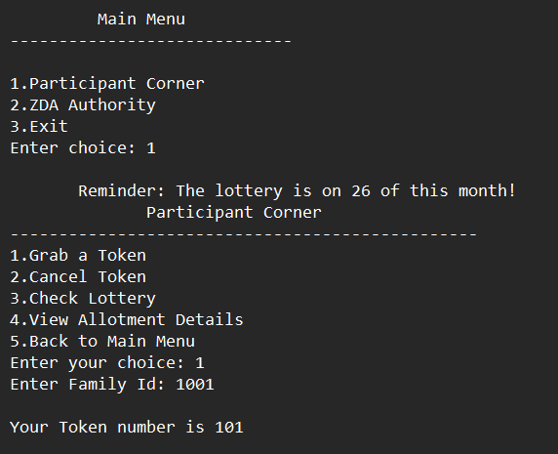

Case 2:

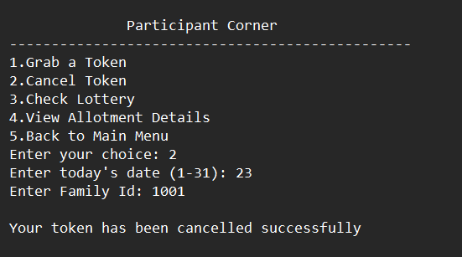

Case 3:

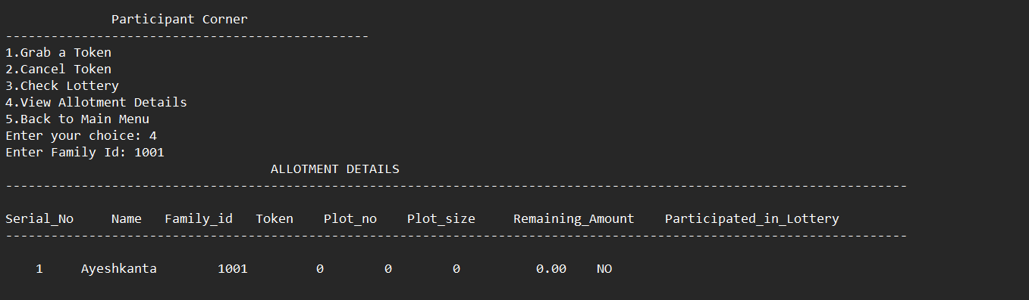

Case 4:

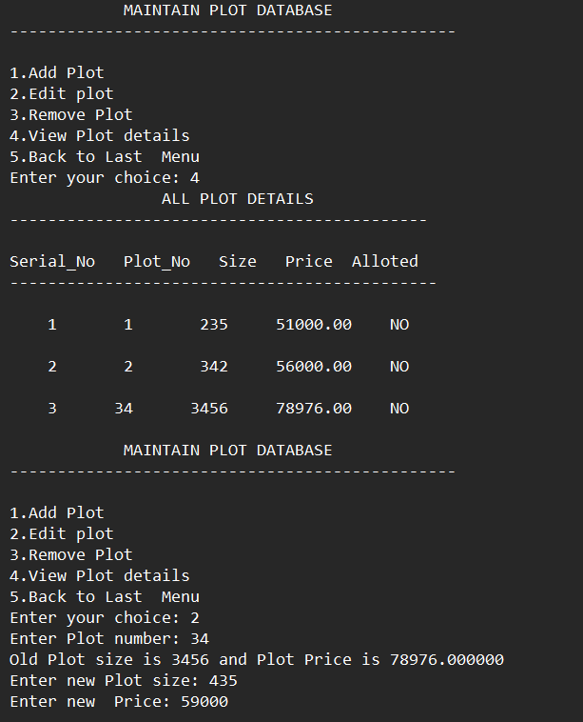

Case 5:

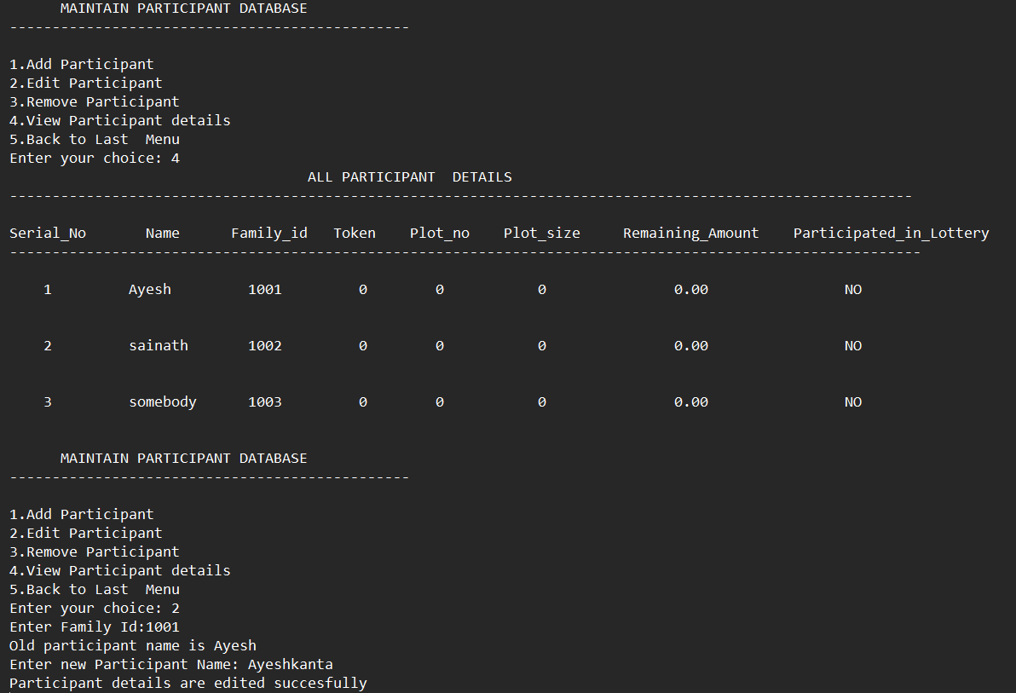

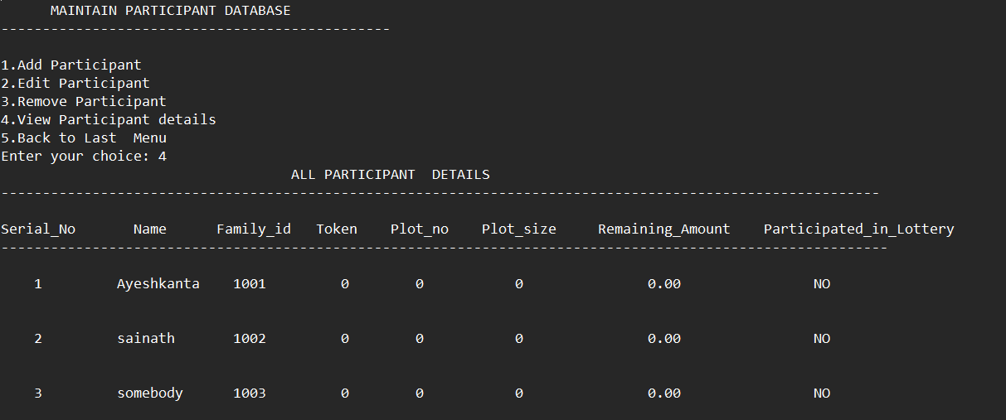

Case 6:

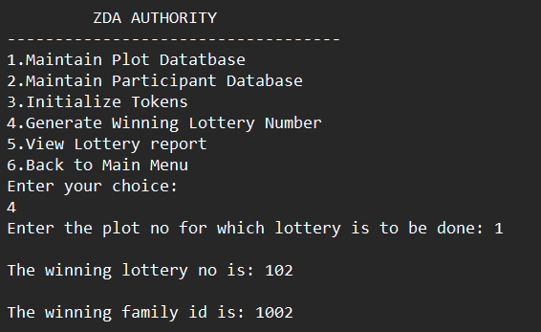

Case 7:

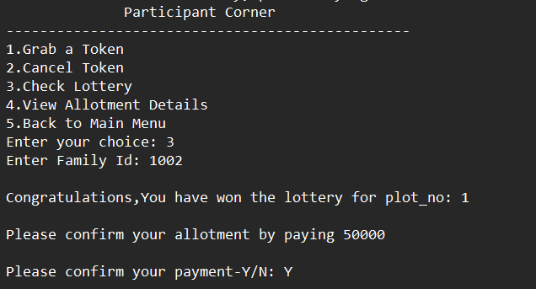

# Requirement Traceability Matrix:

|  |  |  |  |  |
| --- | --- | --- | --- | --- |
| **REQUIREMENT** | **DESIGN MAPPING** | **CODE MAPPING** | **UT MAPPING** | **IT MAPPING** |
| LS_01 | a | Participant_corner |  |  |
| LS_02 | b | ZDA_Authority |  |  |
| LS_03 | c | Initialize_tokens |  |  |
| LS_04 | d | Generate_winning_lottery |  | Test case 6 |
| LS_05 | e | Get_winning_lottery |  |  |
| LS_06 | f | Grab_token |  | Test case 1 |
| LS_07 | g | Cancel_token |  | Test case 2 |
| LS_08 | h | Lottery_confirmation |  | Test case 7 |
| LS_09 | i | View_allotment_details |  | Test case 3 |
| LS_10 | j | add_plot | Test case 3 |  |
| LS_11 | k | edit_plot |  | Test case 4 |
| LS_12 | l | delete_plot |  |  |
| LS_13 | m | view_plot_details |  |  |
| LS_14 | n | add_participant | Test case 1 |  |
| LS_15 | o | edit_participant |  | Test case 5 |
| LS_16 | p | remove_participant | Test case 2 |  |
| LS_17 | q | view_participant_details |  |  |
| LS_18 | r | view_lottery_report |  |  |
| LS_19 | s | list_to_plot_file |  |  |
| LS_20 | t | list_to_participant_file |  |  |
| LS_21 | u | plot_file_to_list |  |  |
| LS_22 | v | paticipant_file_to_list |  |  |
| LS_23 | w | maintain_participant_db |  |  |
| LS_24 | x | maintain_plot_db |  |  |